Unit 3 HW

Note that you have already completed Problem 1 in the For Live Session Assignment. Please include the completed Problem 1 in your homework submission as it will count towards points for the HW.
- In the United States, it is illegal to discriminate against people based on various attributes. One example is age. An active lawsuit, filed August 30, 2011, in the Los Angeles District Office is a case against the American Samoa Government for systematic age discrimination by preferentially firing older workers. Though the data and details are currently sealed, suppose that a random sample of the ages of fired and not fired people in the American Samoa Government are listed below:

Fired
34 37 37 38 41 42 43 44 44 45 45 45 46 48 49 53 53 54 54 55 56

Not fired
27 33 36 37 38 38 39 42 42 43 43 44 44 44 45 45 45 45 46 46 47 47 48 48 49 49 51 51 52 54

        - Check the assumptions (with SAS) of the two-sample t-test with respect to this data. Address each assumption individually as we did in the videos and live session and make sure and copy and paste the histograms, q-q plots or any other graphic you use (boxplots, etc.) to defend your written explanation. Do you feel that the t-test is appropriate?
Yes, a T Test is still appropriate against the American Samoa Government. The samples were collected at random and have a normal distribution. Whether each employees have independence, we are unable to know from the data shown.
        - Check the assumptions with R and compare them with the plots from SAS
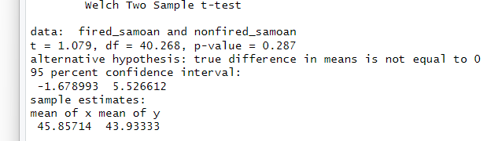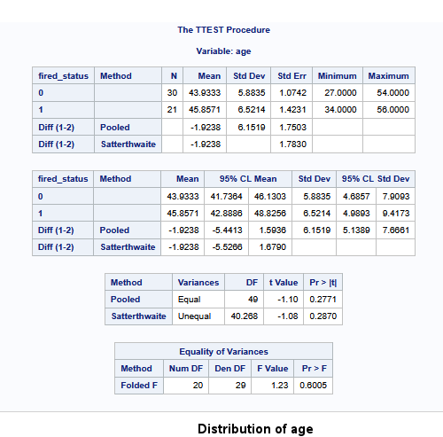
        - Now perform a complete analysis of the data. You may use either the permutation test from HW 1 or the t-test from HW 2 (copy and paste) depending on your answer to part a. In your analysis, be sure and cover all the steps of a complete analysis:
1. State the problem.
2. Address the assumptions of t-test (from part a).
3. Perform the t-test if it is appropriate and a permutation test if it is not (judging from your analysis of the assumptions).
4. Provide a conclusion including the p-value and a confidence interval.
5. Provide the scope of inference.

- H0: MF – MNF = 0 or Ha: MF – MNF != 0
- Both groups are random samples and the given information does not state whether each subject is independent, as we do not know what sections or occupation is subject it, so we should act as if the data is independent. The data also shows a normal distribution. The variance of the samples are not equal.
- Performed Welch’s T Test since the sample size and variance were different
- The active lawsuit against the American Samoan Government claims that the government is discriminiating against the ages of their employees and that they have been firing employees that are older than the employes that were not fired. Assuming that there is no difference in the ages between fired and retained employees, the P-Value would be .287 and 95% Confidence Interval between -1.68 – 5.53. Given that the P-Value is larger than .05 and that 0 is with in the Confidence Interval, we would Fail to Reject the Null Hypothesis. The evidence alone is not enough to assume that the American Samoan Government is discriminating against age and firing their employees based on age.
- The groups were randomly sampled, but were not randomly assigned groups. The study can be generalized to the population, but a causal conclusion should not be made off of the study.
(Steps 3-5 are from your previous HW; you are just putting everything together.)
NOTE: THIS QUESTION SHOULD BE EASY AS YOU ARE SIMPLY FORMATTING YOUR RESULTS FROM EARLIER IN THE ABOVE FORM. (Steps 3-5 are from your previous HW; you are just putting everything together.) IT REALLY JUST EQUATES TO ADDING A STATEMENT OF THE PROBLEM AND ADDRESSING THE ASSUMPTIONS (1 and 2 above). You can basically copy and paste the rest. We are simply putting everything together to make a complete report.
Note: Perhaps you might be wondering at this point in the HW, “Why are we always testing the assumptions of the t-test? Is it the best test? Should we always run the t-test when we can?” These are very good questions and open questions that are up for debate! The one thing that is mathematically proven and not up for debate is that if the assumptions are met, the two-sample t test is the most powerful (in terms of Power = 1 – beta) test in the universe at testing the claim of the difference of means. Two questions may arise here … 1. Do we ever really have the assumptions fully met in the real world and just how much power do we give up at varying degrees of violation of the assumptions? 2. Do we always want inference on the equality/difference of means? We will continue to answer these questions in Unit 4. Also note that we started to answer number two with a t-test of log transformed data. The inference there is on the equality (ratio) of medians which may be a better measure of center when dealing with right or left skewed data!)

- In the last homework, it was mentioned that a Business Stats class here at SMU was polled and students were asked how much money (cash) they had in their pockets at that very moment. The idea was to see if there was evidence that those in charge of the vending machines should include the expensive bill / coin acceptor or if they should just have the credit card reader. However, a professor from Seattle University polled her class with the same question. Below are the results of the polls.

SMU
34, 1200, 23, 50, 60, 50, 0, 0, 30, 89, 0, 300, 400, 20, 10, 0

Seattle U
20, 10, 5, 0, 30, 50, 0, 100, 110, 0, 40, 10, 3, 0

        - Check the assumptions (with SAS or R) of the two-sample t-test with respect to this data. Address each assumption individually as we did in the videos and live session and make sure to copy and paste the histograms, q-q plots, or any other graphic you use (boxplots, etc.) to defend your written explanation. Do you feel that the t-test is appropriate?
No I don’t feel that a T-test is appropriate at least in the current context of the data. Given that one group has strong outliers and the data isn’t normal , we would need to a least transform the data with a log. Or a Permutation Test would provide more insight on the data alone.
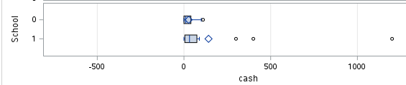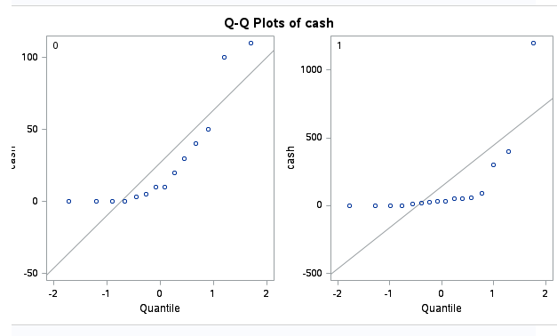
        - Now perform a complete analysis of the data. You may use either the permutation test from HW 1 or the t-test from HW 2 (copy and paste) depending on your answer to part a. In your analysis, be sure to cover all the steps of a complete analysis.
1. State the problem.
2. Address the assumptions of the t-test (from part a)
3. Perform the t-test if it is appropriate and a permutation test if it is not (judging from your analysis of the assumptions).
4. Provide a conclusion, including the p-value and a confidence interval.
5. Provide the scope of inference.
NOTE: AGAIN, THIS QUESTION SHOULD BE EASY, AS YOU ARE SIMPLY FORMATTING YOUR RESULTS FROM EARLIER IN THE ABOVE FORM. IT REALLY JUST EQUATES TO ADDING A STATEMENT OF THE PROBLEM AND ADDRESSING THE ASSUMPTIONS (1 or 2 above.) Steps 3-5 are from your previous HW; you are just putting everything together. You can basically copy and paste the rest. We are simply putting everything together to make a complete report.
- H0: MSMU – MSeattle = 0 or Ha: MSMU – MSeattle != 0
- Given that the Variances are not even close to each other and the sample sizes are off, I suggest a permutation test be ran.
- Ran a permutation Test
- Assuming that the differences between what students had cash on hand between the school are 0, the PValue of the permutation test is .4846 and a a 95% confidence interval of -282.6 – 53.38. Given the evidence, it is not strong enough to assume that the students of either school have more or less cash on hand than the other school.
- The sample was not random, instead was only comprised of students of the business class. The sample cannot be generalized to a population outside of the class and the students were not placed into groups at random either, which prevents us from using the study as a causal claim.

        - Note the potential outlier in the SMU data set. Re-check the assumptions in SAS or R without the outlier. Does this change your decision about the appropriateness of the t-tools? Compare the p-value from the t-test with and without the outlier. Based on your analysis so far, what should we do with this outlier? Consult the outlier flowchart in Section 3.4.
        - We would run both test and report the outputs from both and ensure the audience understands.

- Find the “Education Data” data in the course materials. This data set includes annual incomes in 2005 of the subset of National Longitudinal Survey of youth (NLSY79) subjects who had paying jobs in 2005 and who had completed either 12 or 16 years of education by the time of their interview in 2006. All the subjects in this sample were between 41 and 49 years of age in 2006. Test the claim that the distribution of incomes for those with 16 years of education exceeds the distribution for those with 12 years of education. (Hint: pay careful attention to the ratio between the largest and smallest incomes in each group … also …. is the bigger mean associated with the bigger standard deviation? … Transformation?) You may use SAS or R for this problem but be sure and include your code!
Note: There is some SAS code in the course materials to help you download the data into SAS. It is a very large dataset… “datalines” is not a good idea here! You could also use the File/Import option.
Finally, make sure you present your findings as you would to a client:
- State the Problem.
- Address the Assumptions (graphically and using words).
- Perform the Most Appropriate (Powerful) Test. (In reality, this may be a pooled t-test on the original data, a t-test on the log transformed data, or a permutation test on the original data, since these are the ones we have studied so far. For now, assume you must choose between the pooled t-test on the original data or on the log transformed data.)
- Provide a conclusion including a p-value and a confidence interval.
- Provide a scope of inference.
- H0: M16 – M12 = 0 or Ha: M16 – M12 != 0
- The data does not show a normal distribution and with a visual inspection the variance is very likely to be different. The subjects were not assigned to groups at random and the subjects were not randomly sampled. There are some outliers as well.
- The most powerful test is to ru n a t-test on a log-transfromed data, than run a welch’s test on the data since the variance and the sample sizes are not equal
- The evidence of the study is strong enough to assume that subjects of the study that had 16 years of education have a higher income than the subjects that only had 12 years of education. The Pvalue is less than 2.2e-16, given that the difference in the TRUE mean of incomes, this exact sample would almost never happen. The Confidence interval of -.68 and -.46 is between log transformed data doesn’t mean much to people outside of statistics. Using the Logarithm Laws, we are able to assume that the mean of each sample is the median of each group. Using that logic, the difference between sample means is .57, which would mean that the subjects that had 16 years of education made on average 43% more than people who only had 12 years of education.
- The subjects of the study were only a subset of a National Survey and only a portion of the poluation, we would not be able to generalize the study outside of the survey. The choice not to randomly assigned them groups, prevents them from making a causal inference.

Bonus (5 pts): Create two q-q plots (by hand) for the original data in Chapter 3, question 20 of the text book. A q-q plot for the In-State and a q-q plot for the Out-Of-State data. Show all work by filling in a table like the one below (one for In-State and one for Out-of-State):
Original Data | Percentage for percentiles given number of values | Z-score of original data | Z-score percentiles assuming normal distribution given the values in column 2.

Check your q-q plots by comparing them with the ones from proc ttest. (Run proc ttest but just for the q-q plots. You do not need to run a full hypothesis test.) What would you conclude about the normality of the distributions these data came from?

